**Rectangle**: Represents Entity sets.  
**Ellipses**: Attributes  
**Diamonds**: Relationship Set  
**Lines**: They link attributes to Entity Sets and Entity sets to Relationship Set  
**Double Ellipses:** Multivalued Attributes  
**Dashed Ellipses**: Derived Attributes  
**Double Rectangles**: Weak Entity Sets  
**Double Lines**: Total participation of an entity in a relationship set

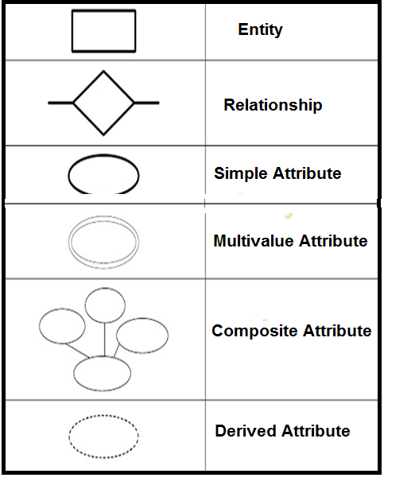

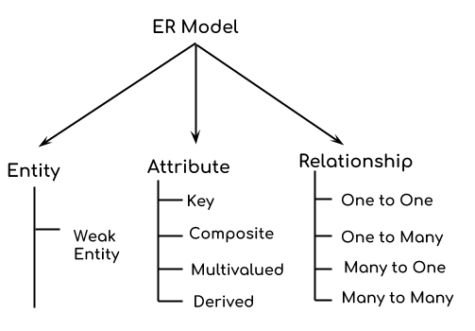

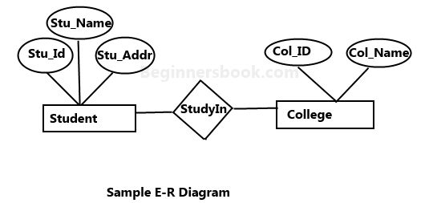

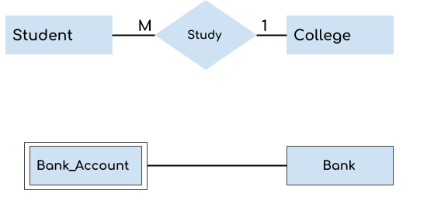

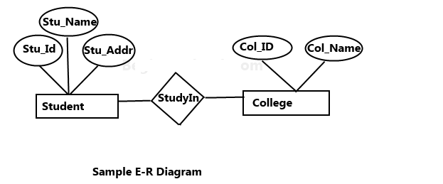

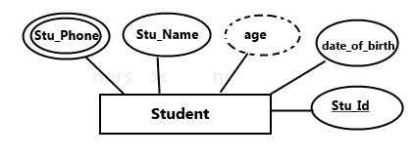

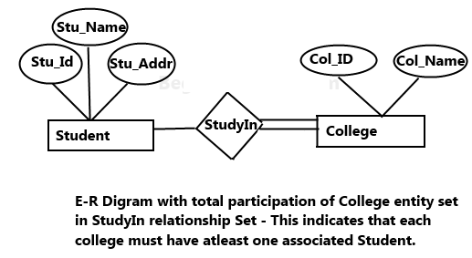

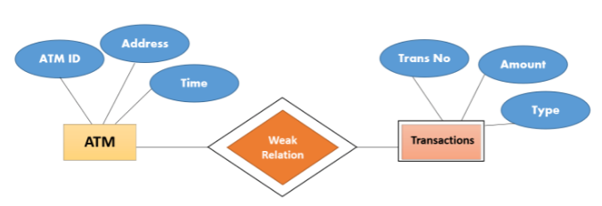

Some examples of ER model are −

**Hospital ER Model**

This is an ER model of a Hospital. The entities are represented in rectangular boxes and are Patient, Tests and Doctor.

Each of these entities have their respective attributes which are −

* **Patients**- ID(primary key), name, age,visit_date
* **Tests**- Name(primary key), date, result
* **Doctor**- ID(primary key), name, specialization

The relationships between different entities are represented by a diamond shaped box.

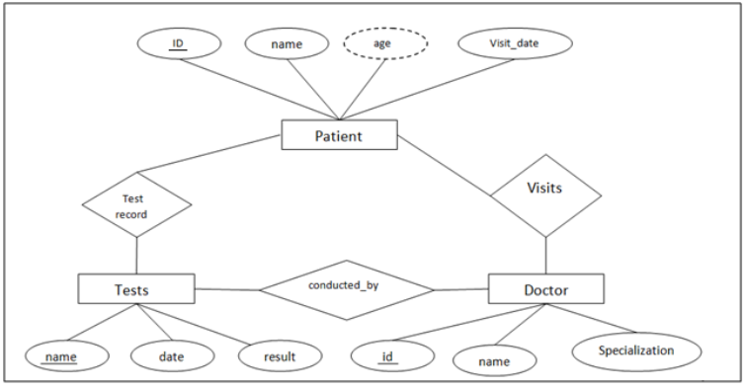

## Company ER Model

The entities in this ER model are Employee, Department and Project. These entities have the following attributes −

* Employee - ENO(Primary Key) , Name, Salary
* Department - DNO(Primary key), Name, Locations
* Project - PNO(Primary key), Name

The relationships in this ER model are represented as Works for and Controls.

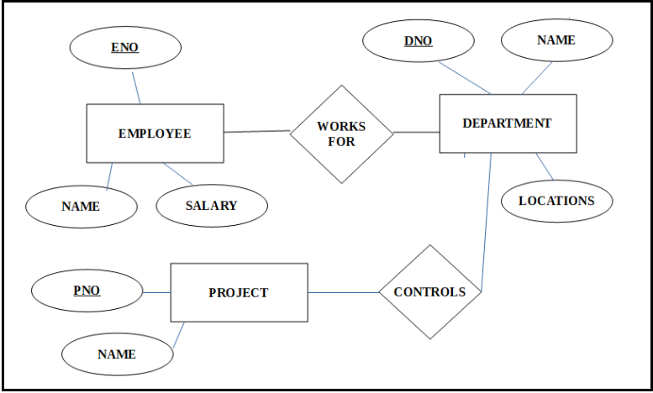

## ER Diagram for Food Ordering System

The ER model includes these entities:

* Restaurant
* Opening Hours
* Week Day
* Coupon
* Menu
* Menu Group
* Menu Item
* Menu Item Extra
* Customer
* Order
* Order Item
* Order Item Extra
* Order Status - the order may be in one of these statuses: Draft, Ordered, Preparing, Checking, Prepared, Delivering, Taken Over and Cancelled.

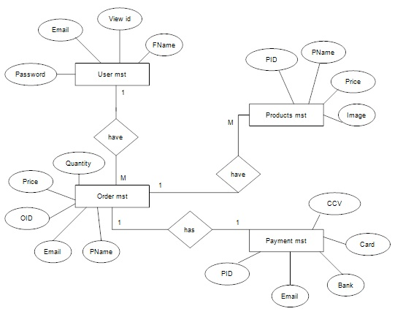

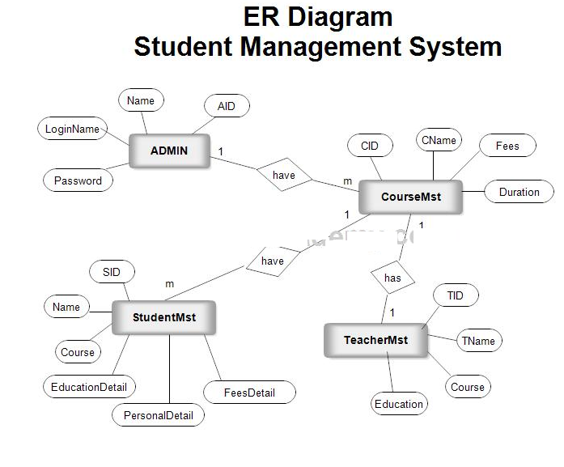

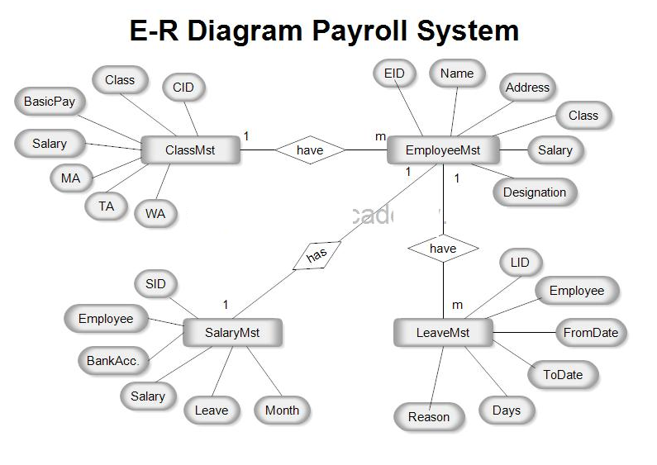

<https://meeraacademy.com/er-diagram-for-student-management-system/>